GENERAL INFORMATION ABOUT THE SYSTEM

ZOSKCTR has a scheduled maintenance window on the last Wednesday of each month between the hours of 4am and 8am eastern time. Expect that the system will be unavailable during this time and plan your activities around it. An email will be sent to instructors if there is a change to this schedule, or if an emergency outage is required.

GENERAL INFORMATION ABOUT USERIDs

Instructor userids start with KC02, while student userids start with KC03. Note that the third position of the userid is the number zero ‘0’, not the letter ‘O’.

The Instructor USERID has RACF authority to look at their Student’s Datasets, however the Students do not have the authority to look at their instructor’s datasets.

The Instructor has the ability to RESET their Student’s passwords using the following proсedure:

GO to Panel 6 (ISPF Command Shell) .

Enter the following to reset a REVOKED Student USERID:

ALTUSER KC03nnn PASSWORD(KC03nnn) RESUME

*Instructors can also reset the passwords for other instructors AT THE SAME INSTITUTION.
The following rules apply to 3270 passwords:
- Passwords must be at least six characters in length.
- Passwords cannot be more than eight characters in length.
- Passwords can only be alphanumerics (i.e., either numbers or letters).
- Passwords are NOT case sensitive in this system.

Please be responsible and purge your job output from SDSF when it is no longer needed.

After the end of the course, the student userids and all associated datasets are deleted. When you request student userids, please provide the course name, start and end dates as well as the number of student userids needed. Userids get recycled after a certain time frame unless specified in the end date.

Student and Instructor data is not backed up. It is the responsibility of instructor and students to backup data to a different dataset.

System support for the Marist Hub is provided solely through email to KCTRADMIN@marist.edu; please do not contact the Marist Help Desk for support, as they do not have a means to reset passwords or provide any other assistance.
LOGGING ON TO THE MARIST HUB SYSTEM
Before you can connect to ZOSKCTR2( MARIST HUB), you will need to obtain or own a 3270 emulation program, such as one of the following:
- Hummingbird
- VistaTN3270 http://www.tombrennansoftware.com/download.html
- Pcomm v6

Please note the production version of VISTA TN3720 is v1.27; this supports all current Windows releases including Windows 7. Previous versions may not work with Windows 7.

Access ZOSKCTR using name ZOS.KCTR.MARIST.EDU port 1023. If port 1023 does not work, you can try the ‘backdoor’ using port 80. You will have to personalize the emulation software according to your hardware definition. To reach ZOSKCTR system on port80 go to: portforward.kctr.marist.edu

To logon to the Unix System Services interface, use port 23. You cannot access TSO from port 23, only the Unix (OMVS) interface.

USING VISTA EMULATION PACKAGE SOFTWARE

Download and then install by running the program. After you install you should have an icon for "Vista 127.exe". Next, start this program and install the software. After the install you will have a folder which has an icon for the “Vista Standard Session”. Click on this icon. You will receive a screen that looks like:
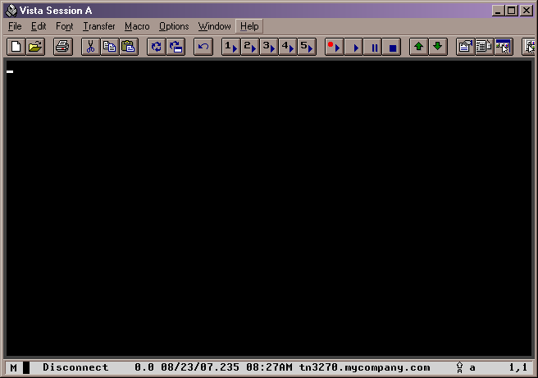

Click on Help menu option and then Enter-Registration-Code.
Enter the name and code as follows: Marist College Student License 644EMDM1H4.

You will now need to click on the Vista icon (I move this icon to the desktop to use for startup of TSO) and setup your terminal definition to connect to the mainframe hub at Marist College.

VISTA
The following Terminal Definition should be used when you are connecting to ZOSKCTR – AFTER ENTERING FOLLOWING – CLICK CONNECT.
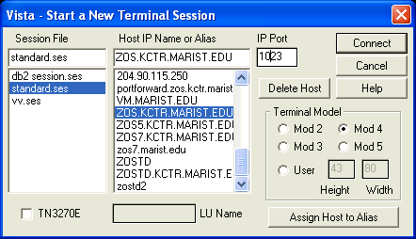

SIGNING ONTO TSO

Start the Vista Standard Session by double-clicking on the icon. You should now have a screen that is similar to:
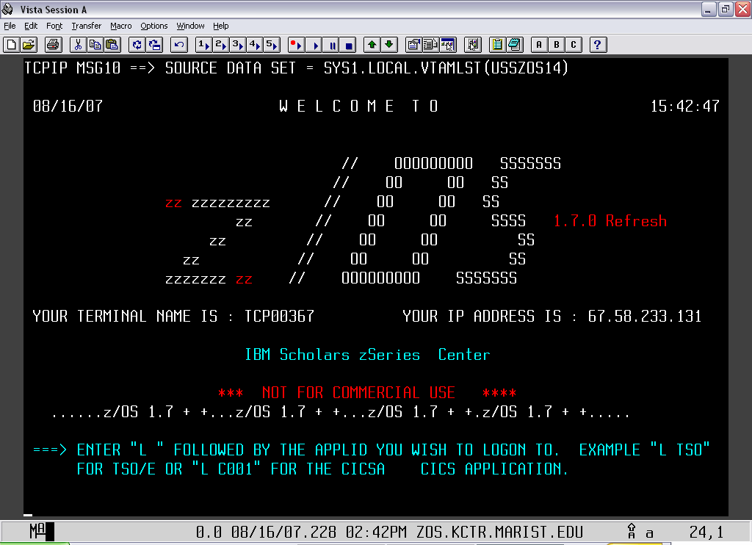

The cursor is positioned at the bottom of the screen. Key in "L TSO" and then hit the CTRL key (NOTE: this is the enter key in TSO).
The next screen begins your signon:

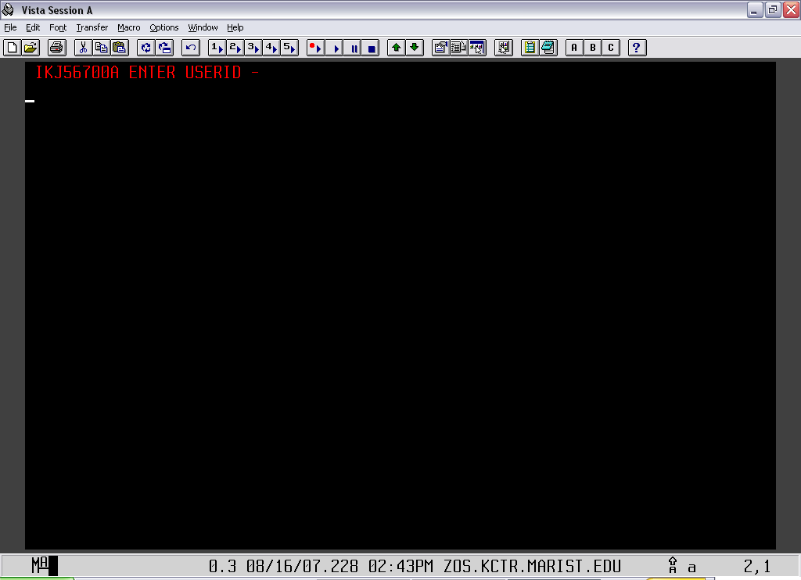

Enter the userid given to you by your instructor and then the CTRL key.

You will next get a screen that looks like:

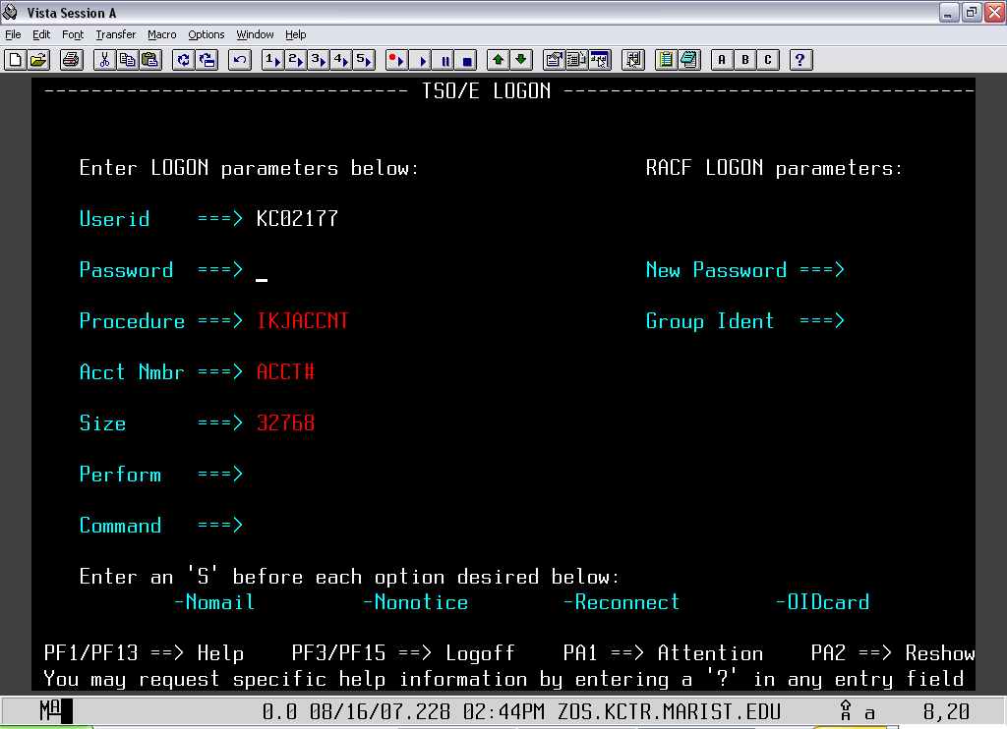

The cursor is positioned in the password field. For your first time, the password is the same as the userid. You will be asked to choose a new password. This account is yours and yours alone. Sharing your account with another student will be considered dishonest.

After you have entered and/or changed your password hit the CTRL key.

You will now see this screen:

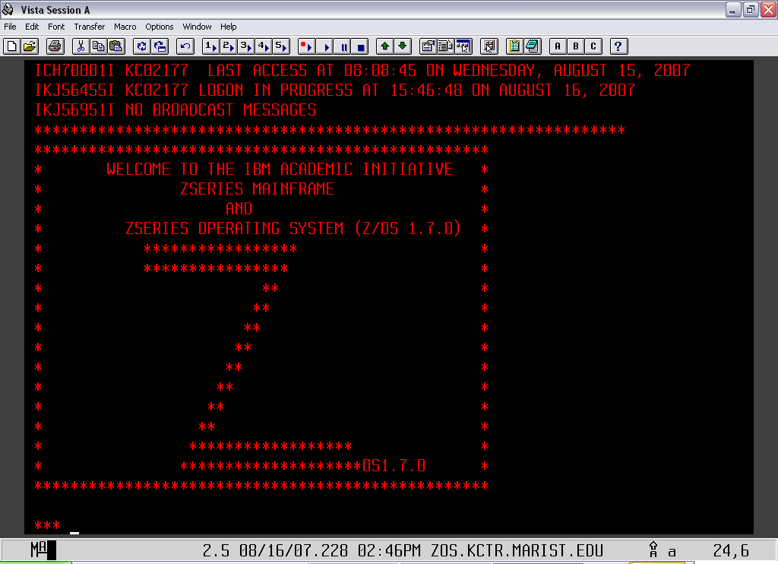

Hit the CTRL key again.

Now you are in TSO and should have a screen that looks like:

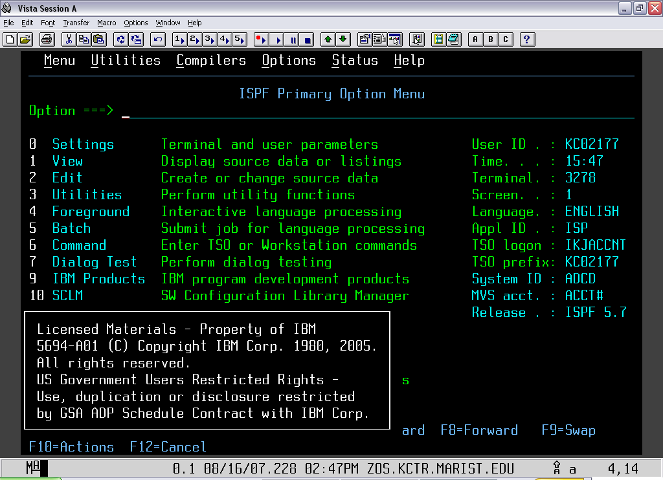

EDIT KEYBOARD “ENTER” KEY

1.) First, you need to open TSO and logon. Once you have done that, you will get to the Primary Option Menu. At the top of the page, find where it says Options and click on it. Then, click the option keyboard edit (as shown below).

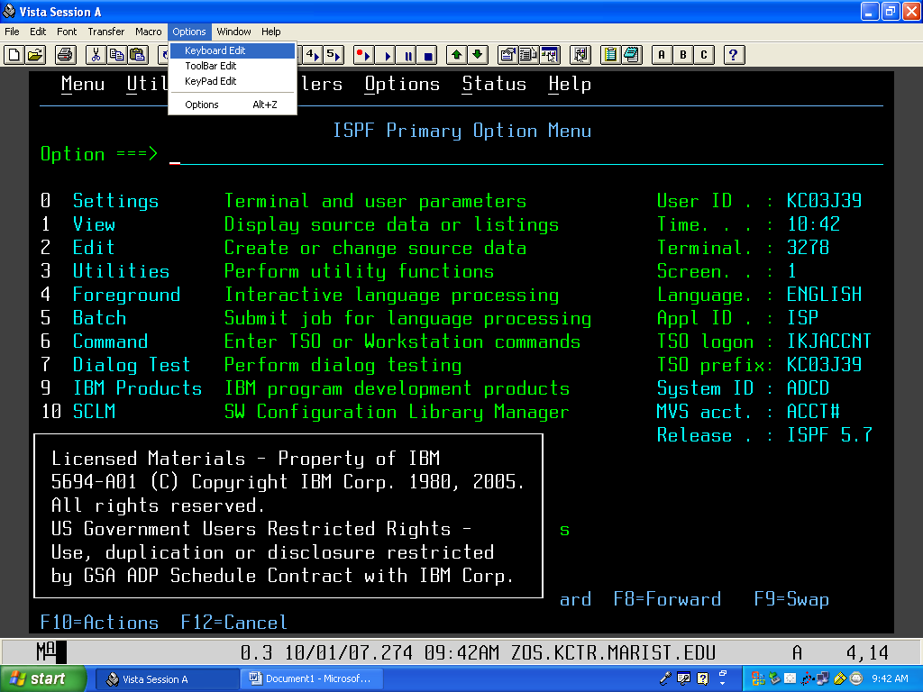

2.) Once you have clicked on the Keyboard Edit button, the following will appear.

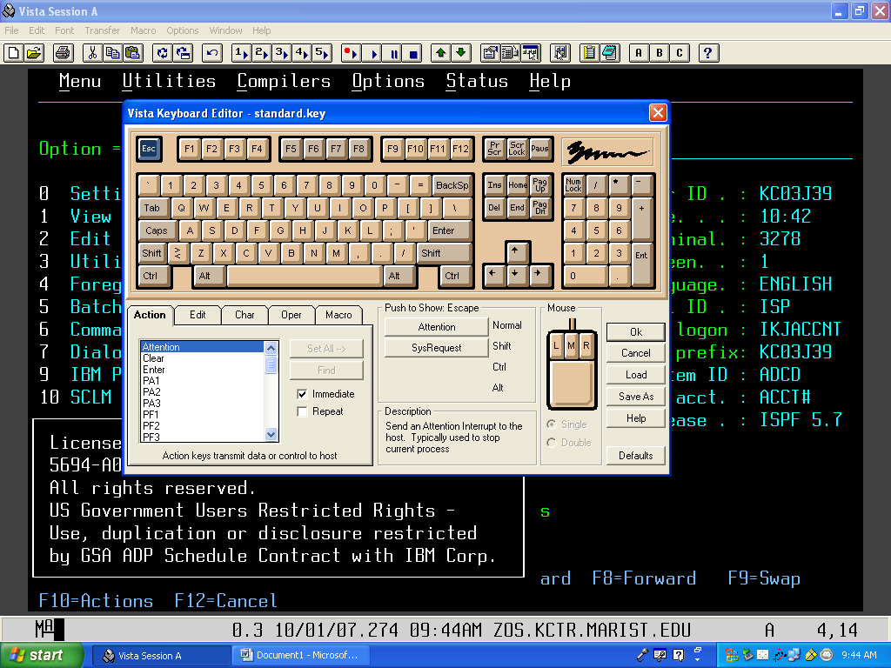

3.) Next, click on the Enter button (it will highlight in blue). At the bottom left of this window you will see a set of tabs labeled ‘Action, Edit, Char, Oper, Macro’. Make sure you are in the Action tab and find where it says Enter. Click on the word enter, under where it says ‘Push to Assign Enter’ click on the button to the left of the word Normal. The word Enter will then appear in this button.

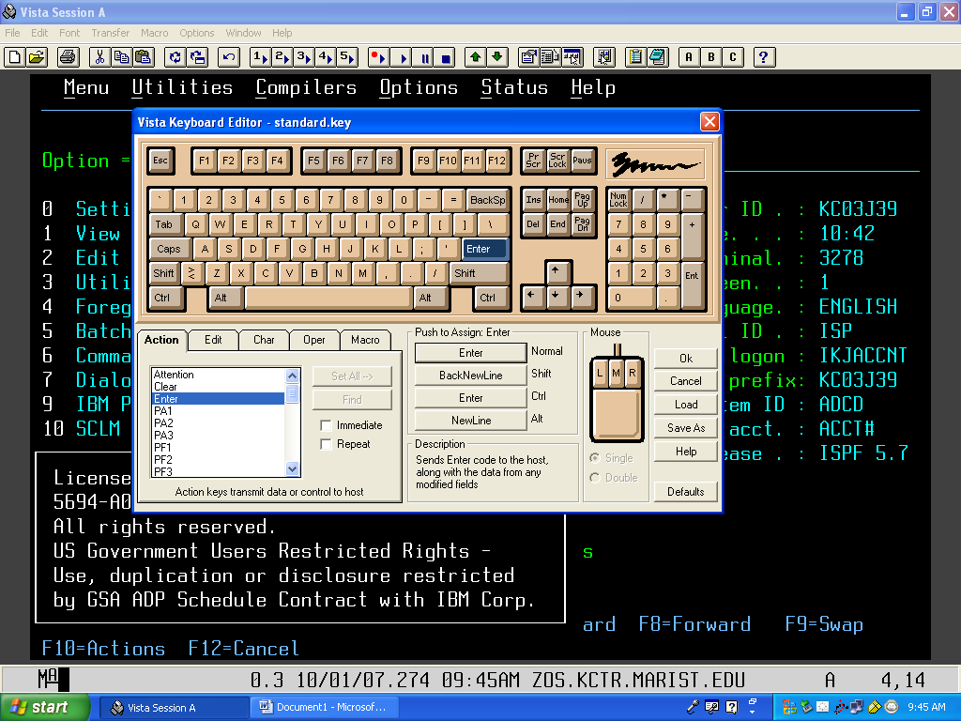
Click enter key

Click Action tab & select Enter
Click here to assign Enter key

4.) To assign the function (New Line) to the Ctrl key, click on the Ctrl key as shown below. In the bottom left box, click on the tab Edit and then on the word New Line. Next, under where it says Push to Assign Ctrl-R, click on the button to the left of the word Normal.

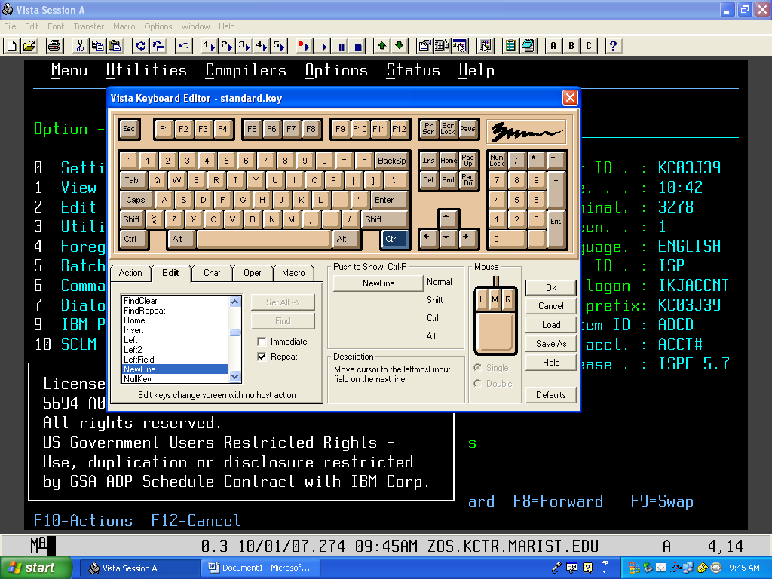
Click on the Edit tab and select NewLine
Click on the Ctrl key
Click here to assign NewLine to Ctrl key

5.) Finally, click Ok. It will then ask you if you want to save the keyboard changes, click Yes.

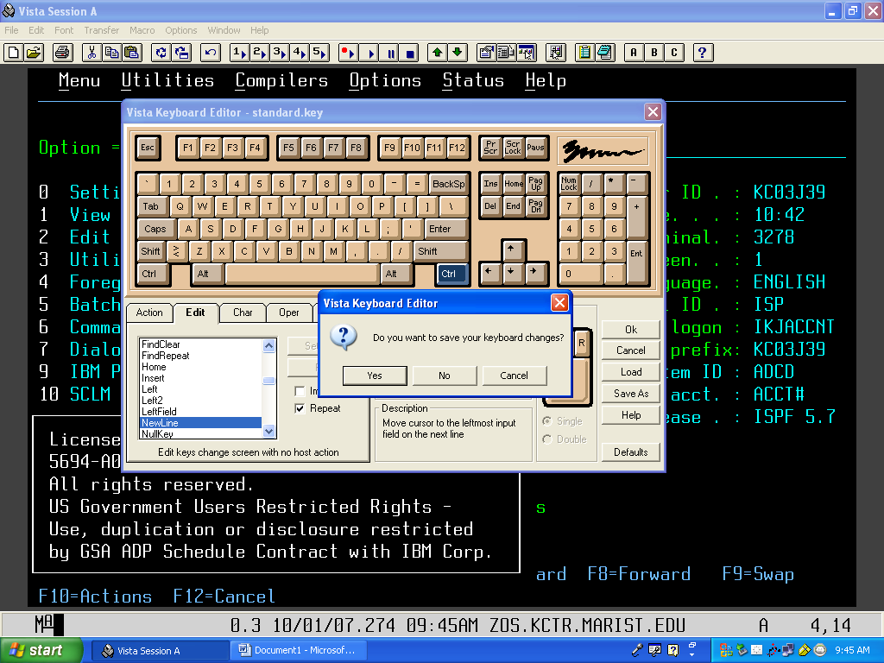
Click Ok
Click Yes to save

6.) Finally, a box will pop up that says Save Keyboard File. Just click Ok. Then your Enter key is assigned to the Enter function, and your R-Ctrl key is assigned to the NewLine function.

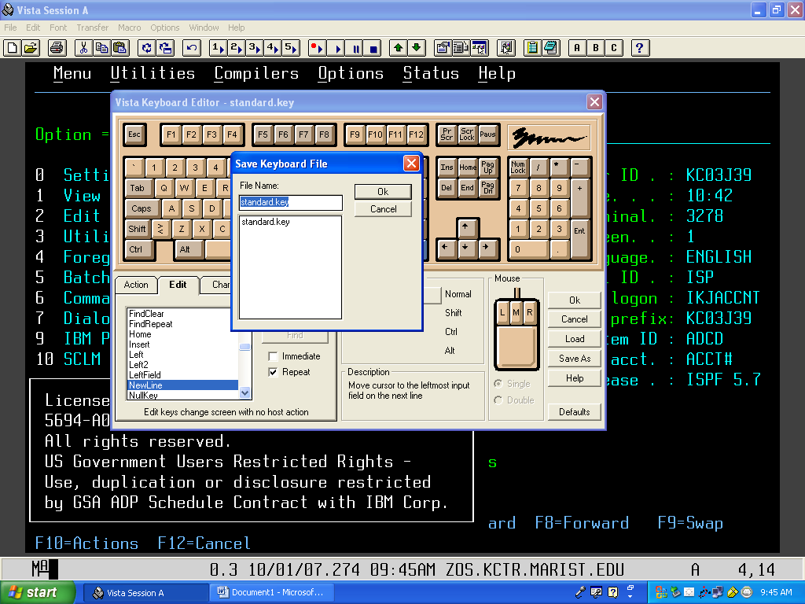
Just click Ok

**NOTE**
To change any other key on the keyboard, you will follow the exact same steps as mentioned above. However, make sure you track what buttons you change in case one function doesn’t work as you thought it was going to or in case you decide later you would like to change the buttons back to the way they were.

PURGE OUTPUT QUEUE OF YOUR EXECUTED PROGRAMS

If your output queue is becoming quite full or you no longer need specific output you can purge any/all of them from the output queue. To do this type P next to the job(s) that you do not want to be displayed anymore and that job will be purged from the system (no longer available).
Before purge:
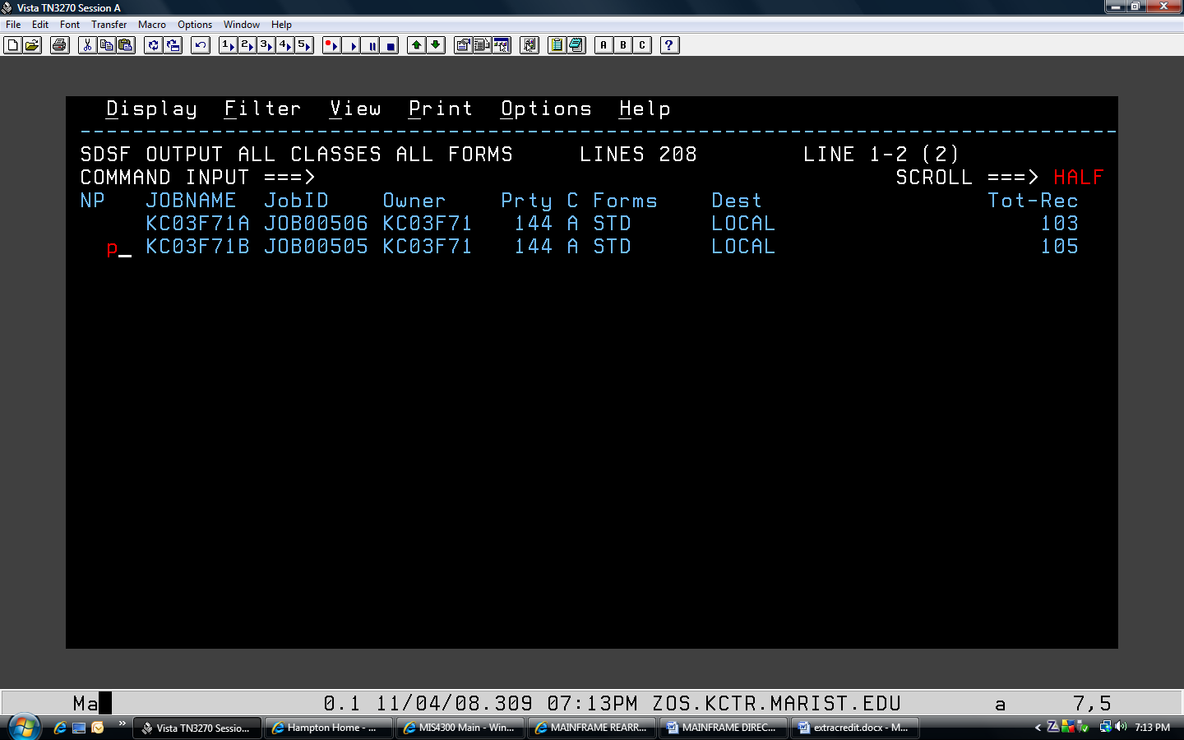

After purge:

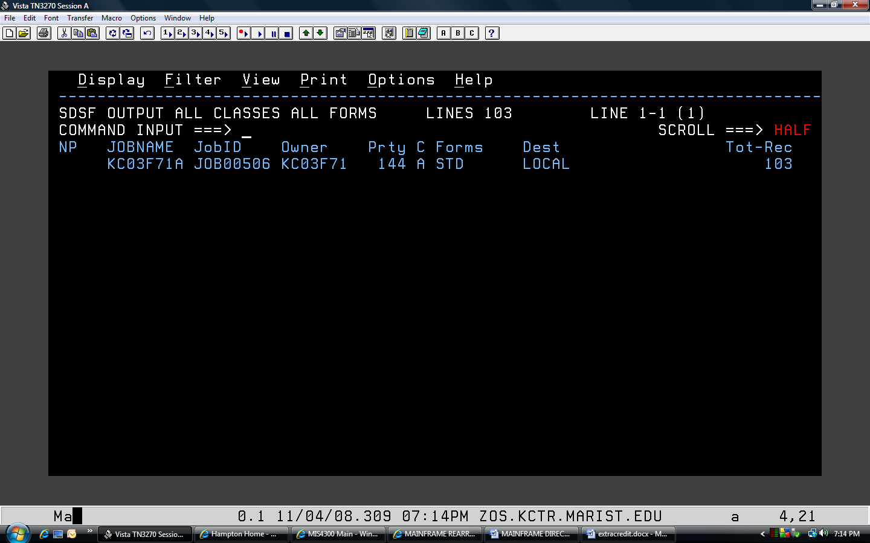

LOGOFF TSO

To logoff TSO, from the main menu hit F3. You should now see a screen similar to:

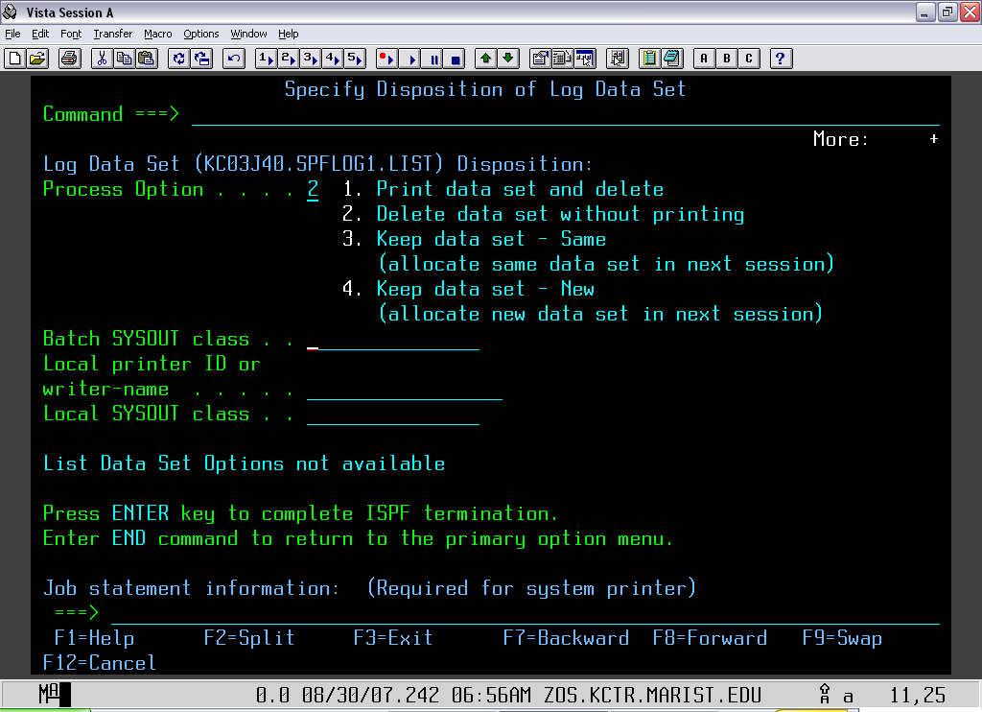

Type in 2 and then CTRL. You should now be at a READY screen. Type in LOGOFF and hit CTRL. Wait a few seconds and it will return to the Z/OS screen. Now exit out of the applications. You can re-logon anytime after this if you need to.

ABEND MESSAGES – FIND OUT WHAT THEY MEAN USING TSO

- Rather than going outside of TSO, when you receive an ABEND look at the code that it gives you.

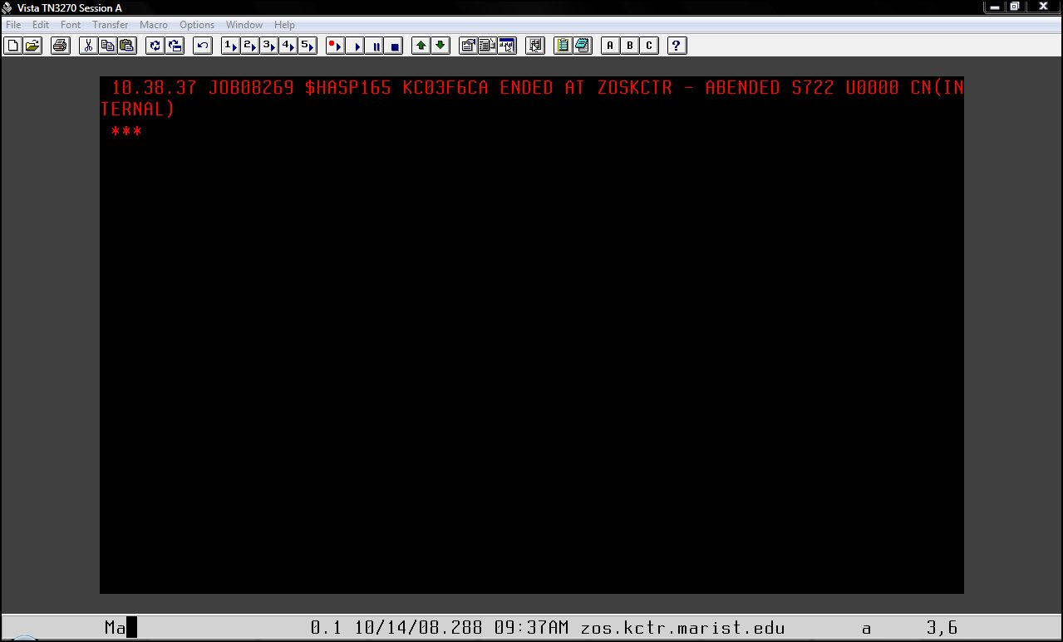

- In this case it would be S722. Go back to your command line and enter in “QW S722” and you should get…

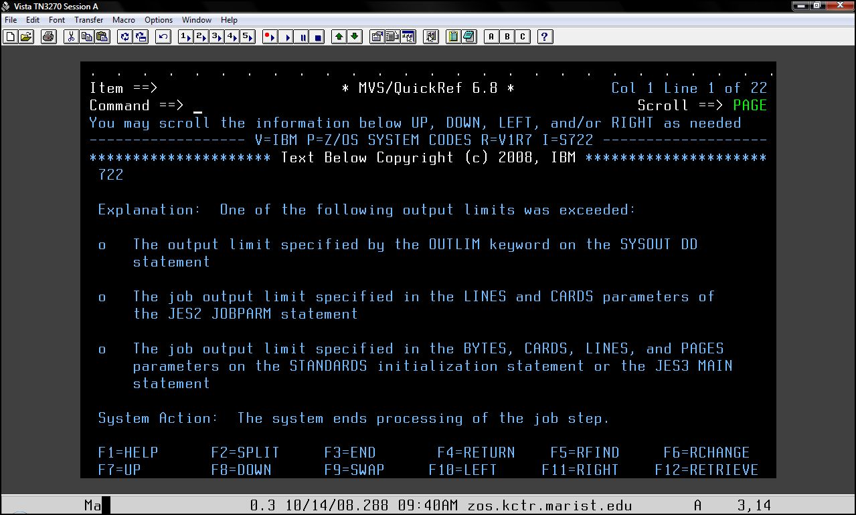

CONNECTING TO UNIX SYSTEM SERVICES (USS)

Connecting to ZOSKCTR2's USS will require using PUTTY or TELNET.

The z/OS system can be accessed using USS PUTTY (TELNET)...
Where it asks for Host Name or IP Address enter zos.kctr.marist.edu
For PuTTY make sure you put in the HOST NAME. Should Use SSH Port 22.
Depress the OPEN Key to get the session started.

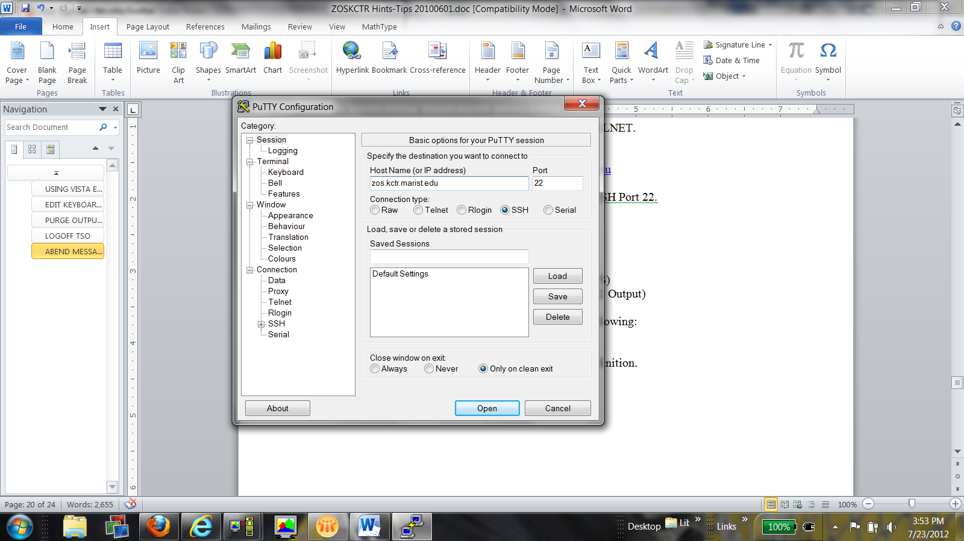

Accessing ZOSKCTR2(z/OS 1.12) for RDZ (PORT 4035 for MVS)
Accessing ZOSKCTR2(z/OS 1.12) for RDZ (PORT 6715 for JES2 Output)

Personalize the emulation software according to your hardware definition.

Some solutions to problems people have had trying to connect to Marist Hub.
1.) Using Hummingbird set the "Negotiate SSL"
2.) To enter 3270 Commands, define the ENTER Key for VistaTN3270.
The KEY definitions 'Right CTRL Key' will have to be defined as the ENTER KEY.
3.) If you cannot ping the address (zos.kctr.marist.edu), you have a firewall problem.
4.) If you are using Filezilla, you cannot specify 1023 as the port but let it default to either 20 or 21.
For a description of the Different Enterprise Courses go to:
www.ibm.com/university/zseries/resources.html
JES2 SYSOUT Information for the ZOSKCTR2 System:
MSGCLASS Definition.....
MSGCLASS=H is used if you want the job to be in the HELD queue. This is the Held Output Queue.
MSGCLASS=A is the normal SYSOUT which will be deleted from the system every hour. This would be the OUTPUT queue( SDSF).
MSGCLASS=5 is used if you want the SYSOUT deleted.
MSGCLASS=9 is also used to delete SYSOUT.
PDS= ZOSKCTR.PROCLIB
(IGYWC) ............COBOL Compile .....................
(IGYWCL) .........COBOL Compile and Load(Link Edit).....................
(IGYWCLG) ..........COBOL Compile, Load(LinkEdit) and Go .......................................................
JCL required to run the COBOL Programs, JCL examples are included below to help Students COMPILE, COMPILE and Link or CLG.
The enhancements may help you or give you some interesting challenges.

Students can create a COBOL program(file) and then use it as input to the following

COBOL COMPILE, LINK and GO JCL EXAMPLE:
//STUDENT JOB <- - - - - - - - - - - - - - - - - - - - - - YOUR JOB CARD
//COBOL1 EXEC IGYWCLG,REGION=50M,
// PARM.COBOL='TEST,RENT,APOST,OBJECT,NODYNAM,LIB,SIZE(1048376)'
//* STEPLIB IS RELEASE DEPENDENT
//COBOL.STEPLIB DD DSN=IGY510.SIGYCOMP,
// DISP=SHR
//COBOL.SYSIN DD DISP=SHR,DSN=STUDENT.COBOL.PROGRAM
//* {NAME OF THE PROGRAM(file) TO COMPILE}
//GO.INFILE DD DISP=SHR,DSN=STUDENT.INDATA
//* {INPUT FILE FOR GO STEP(OPTIONAL)}
//GO.OUTFILE DD DISP=SHR,DSN=STUDENT.OUTDATA
//* {OUTPUT FILE FOR THE GO STEP(OPTIONAL)}
COBOL COMPILE, LINK JCL EXAMPLE:
//STUDENT JOB <- - - - - - - - - - - - - - - - - - - - - - YOUR JOB CARD
//COBOL1 EXEC IGYWCL,REGION=250M,
// PARM.COBOL='TEST,RENT,APOST,OBJECT,NODYNAM,LIB,SIZE(1048376)'
//COBOL.SYSIN DD DISP=SHR,DSN=STUDENT.COBOL.PROGRAM
//* {NAME OF THE PROGRAM(file) TO COMPILE}
COBOL COMPILE JCL EXAMPLE:
//STUDENT JOB <- - - - - - - - - - - - - - - - - - - - - - YOUR JOB CARD
//COBOL1 EXEC IGYWC,REGION=250M,
// PARM.COBOL='TEST,RENT,APOST,OBJECT,NODYNAM,LIB,SIZE(1048376)'
//* STEPLIB IS RELEASE DEPENDENT
//COBOL.STEPLIB DD DSN=IGY510.SIGYCOMP,
// DISP=SHR
//COBOL.SYSIN DD DISP=SHR,DSN=STUDENT.COBOL.PROGRAM
//* {NAME OF THE PROGRAM(file)TO COMPILE}
The High Level Assembler can be used by using the following PROCS found in the following PROCLIB::
PDS= ZOSKCTR.PROCLIB
ASMAC - for compile.
ASMACL - compile and LKED
ASMACG - ASM and EXECUTE(GO)
ASMACLG - ASM, LKED, and GO

> Loadlibs - you shouldn't need your own, just compile the code into the
TSOECCC.CICSTS12.STUDENT.LOADLIB. DSN is already in the RPL
ZPROF.ZSCHOLAR.LANG.CNTL has jcl for cobol and other langs. Tell them to
**COPY FROM THIS MASTER DATASET** and use their own copy. There are other
ZPROF sample datasets that they might find helpful;

Getting output from ZOSKCTR2 to submit to your instructor:
We have a product called XMITIP installed on ZOSKCTR2 that allows you to email job output (or other datasets) to your email id. To use XMITIP for job output, first go into SDSF. Along the top line you will see several pulldown menus, Display, Filter, View, Print, Options, Help. Put your cursor on Options and hit enter, this will bring the Options menu onto the screen:

Display Filter View Print Options Help
----------------------------- +---------------------------------------------+ -
HQX7740 ----------------- SD | 1. Set action character display... | -
| 2. Find limit... |
DA Active users | 3. Change include SYSIN to ON |
I Input queue | 4. Set bookshelf... |
O Output queue | 5. Set display values to ON |
H Held output queue | 6. Set screen characteristics... |
ST Status of jobs | 7. Set delay for responses... |
| 8. Set communications timeout... |
LOG System log | 9. Set console name... |
SR System requests | 10. Set search characters... |
MAS Members in the MAS | 11. Assign PF keys... |
JC Job classes | 12. Change show PF keys to OFF |
SE Scheduling environments | 13. Set language for help and tutorial... |
RES WLM resources | 14. Set cursor option... |
ENC Enclaves | 15. Set confirmation to ON |
PS Processes | 16. Operlog limit for filter... |
| 17. Set date format... |
END Exit SDSF | 18. Set log default... |
| 19. Set default browse action... |
Licensed Materials - Property +---------------------------------------------+

5694-A01 (C) Copyright IBM Corp. 1981, 2007. All rights reserved.
US Government Users Restricted Rights - Use, duplication or
disclosure restricted by GSA ADP Schedule Contract with IBM Corp.

Select option 11. Assign PF keys…. which brings up this screen that allows you to change your PFkey settings. Your PF key 6 will likely be set to 'BOOK'. Each of the PFkey lines is editable:

PF Key Definitions and Labels - Primary Keys

Number of PF Keys . . . 24 Terminal type . : 3278

PF1 . . . HELP
PF2 . . . SPLIT
PF3 . . . END
PF4 . . . RETURN
PF5 . . . IFIND
PF6 . . . pt odsn sdsf.list * new;pt;pt close;tso %xmitsdsf sdsf.list
PF7 . . . UP
PF8 . . . DOWN
PF9 . . . SWAP
PF10 . . LEFT
PF11 . . RIGHT
PF12 . . RETRIEVE

PF1 label . . PF2 label . . PF3 label . .
PF4 label . . PF5 label . . PF6 label . .
PF7 label . . PF8 label . . PF9 label . .
PF10 label . . PF11 label . . PF12 label . .

Press ENTER key to display alternate keys. Enter END command to exit.

Change whichever PFkey you like to call the XMITIP program function (most people change PF6, as in the above screenshot) :

pt odsn sdsf.list * new;pt;pt close;tso %xmitsdsf sdsf.list

Then PF3 to end. Your pfkeys on the bottom of the screen when you are in SDSF should now show “=pt odsn” for the one you changed to XMITIP.

Now change to the ST display in SDSF, select your job output that you would like to email to yourself, and while viewing your output, click PF6 (or whatever one you made for XMITIP). You will get a dialog like this:

---------------------------- E-Mail Dialog 09.03 ----------------------------
Command ===>

Recipient Address ===> your.email@your.server.edu
Message, DSN, *, ? ===>
Edit Message DSN ===> Yes or No

Execution Mode ===> Prompt I ISPF B Batch C Config P Prompt D Debug
Subject ===> Report from MVS/TSO
Configuration File ===>
Default Settings ===> Yes or No

CC Address ===>
BCC Address ===>
AddressFile ===>
Delivery Settings ===> Yes or No (FollowUp, Import, Prior, Sens)

Attachment DSN or ? ===> 'userid.SDSF.LIST'
Attachment Name ===> SDSF1148.rtf
Format (?=prompt) ===> RTF/l/14/-let
Settings ===> Yes or No

Field level help available via PF1

Fill in the recipient address with your userid, and ensure the rest of the fields match this (the attachment names may be slightly different, that is ok). Hit enter. Another dialog may come up for “E-Mail Attachment Details”,
Just take the defaults and hit enter. The next screen will display “XMITIP Send Confmrmation” (yes is spelled wrong…) which shows the command generated from the panels you just entered. Press Enter to send your output. You will be put into a ‘browse’ session with the complete information from XMITIP, you can read it if you like or just F3 out of it. You should get a message saying your file was “spooled to MAILER”, just hit enter to pass that. Your email should be sent to your email address, with the output file you selected as an attachment.
==============================================================
Contact Information:
email: kctradmin@marist.edu

Technical Systems Services
Information Technology
Marist College
3399 North Road
Poughkeepsie, NY 12601

